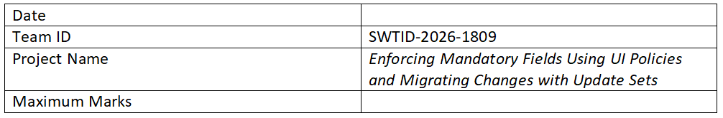

Project Design Phase-II

Data Flow Diagram & User Stories
Project Title: Enforcing Mandatory Fields Using UI Policies and Migrating Changes with Update Sets

Data Flow Diagram (DFD)
Level 0 DFD Description:
User interacts with ServiceNow forms -> UI Policies enforce mandatory fields -> Client Scripts validate input -> Data is stored in ServiceNow database -> Update Sets capture configuration changes -> Update Sets are migrated across environments.

User Stories
User Type | Functional Requirement (Epic) | User Story Number | User Story / Task | Acceptance Criteria | Priority | Release
End User | Form Validation | USN-1 | As a user, I want mandatory fields to be enforced so that I provide complete data. | Form cannot be submitted without mandatory fields | High | Sprint-1
End User | Form Validation | USN-2 | As a user, I want visual indicators for required fields. | Mandatory fields are highlighted | High | Sprint-1
Developer | UI Policy Management | USN-3 | As a developer, I want to configure UI Policies. | UI Policies applied successfully | High | Sprint-1
Developer | Client Script Validation | USN-4 | As a developer, I want to add client-side validation. | Scripts validate input correctly | Medium | Sprint-2
Admin | Update Set Management | USN-5 | As an admin, I want to capture changes in update sets. | Changes are tracked in update sets | High | Sprint-1
Admin | Update Set Migration | USN-6 | As an admin, I want to migrate update sets between instances. | Changes deployed successfully | High | Sprint-2

